Local Transportation Guide
From airport to Tsinghua University/your hotel:
Taxi：
- Taxi ranks are located at Terminal 1 (Gate 1, outside on F1), Terminal 2 (Gates 5 - 9 on F1) and Terminal 3 (follow signs). Taxis are metered and charge ¥13 for the first 3km, ¥2.3 per additional km. Additional surcharges apply for late night trips and trips over 15km distance or under 2km distance. It usually takes around ¥150 to get to Tsinghua depending on the traffic plus a ¥10 fee for the toll gate.
- Please beware of taxi scams at the airport. Do not make contact with taxi touts at the airport (sometimes they hang around at the International Arrivals exit and dressed like security personnel), or anywhere else for that matter. Go straight to the taxi queue; this is clearly signed - directly outside Terminals 1 & 2, and outside the basement level of Terminal 3. Do not pay the fare prior to reaching your hotel. There are scams whereby you buy a "ticket" to a taxi that will take you to the hotel. All the official taxi in Beijing has a licens plate starting with “京B”. Please refer to the following links for more information:
Taxi information at Beijing Capital airport
Taxi scam at Beijing Capital Airport
- Show the following addresses to the taxi driver
  - If you are coming to Tsinghua university directly, please ask the driver to take you to您好，请将我带到：
北京市海淀区清华大学
  - If you stay at JiaSuo hotel on campus, please show the following address to the driver:
您好，请将我带到：
北京市海淀区清华大学甲所
Tel：+86-10-62793166
  - If you stay at JingChunYuan hotel on campus, please show the following address to the driver:
您好，请将我带到：
北京市海淀区清华大学近春园宾馆
Tel: +86-10-62784008
  - If you stay at Wenjin hotel, please use the following address:
您好，请将我带到：
中国北京市海淀区成府路清华科技园
文津国际酒店
Tel: +86-10-62525566
  - If you stay at FX Hotel, the address is
您好，请将我带到：
北京市海淀区北四环西路68号（北四环海淀桥西南侧）
富驿时尚酒店（北京中关村店）
Tel: +86-10-58986688
- In case of any trouble, please feel free to contact (or let the taxi driver contact) us

Wenbin Yan
Assistant professor, YMSC
Tsinghua University
Cell: 86-15510369164
如有疑问请致电：
清华大学丘成桐数学中心
颜文斌
电话：15510369164

Subway:
- Station locations:
Terminal 2: B2 of Parking Garage No. 2
Terminal 3: F2 of Parking Garage No. 3
- Route 1:
  - Take the Express Railway, and get off at San Yuan Qiao Station.
  - Change to Subway Line 10 (Way to Tai Yang Gong), and then change again at Hai Dian Huang Zhuang Station.
  - Get on Subway Line 4 (Way to An He Qiao Bei), get off at Yuan Ming Yuan Station.
  - Walk about 300 meters to the east; you will arrive at the west gate of Tsinghua University.
- Route 2:
  - Take the Express Railway, and get off at San Yuan Qiao Station.
  - Change to Subway Line 10 (Way to Tai Yang Gong), and then change again at Zhi Chun Lu Station.
  - Take Subway Line 13 (Way to Dong Zhi Men), and get off at Wu Dao Kou Station.
  - Walk about 400 meters to the west until you reach a huge intersection. Turn right and walk another 400 meters, you will reach the main gate of Tsinghua University.
- Subway to other hotel
  - Wenjin Hotel: take route 2 and get off at Wu Dao Kou Station. Walk about 900m to the west to get to the hotel. The hotel is next to the south gate of Tsinghua University.
  - FX Hotel: take route 1 and when you are on Subway Line 4, get off at Zhong Guan Cun Station. Then walk about 1000m to the west.
Local commute:
- If you stay on campus, Jin Chun Yuan hotel is within walking distance to YMSC and the main dining facilities
- The center is happy to lend bicycles to visitors. Please contact （请问是哪位老师负责自行车） to sign up.
- Wenjin Hotel: the south gate of campus is just to the north of the hotel.
- FX Hotel: please refer to the following link to go from FX hotel to the west gate.
FX hotel to west gate
Campus directions:
- The campus map is attached in the following page. The larger version can be found at this link: Campus map
- YMSC is closer to the west gate and the northwest gate.
- Please be prepared to present your invitation letter/e-mail at the gate.
- Taxi can drive through the main gate, the south gate, the northwest gate and the northeast gate.
We are looking forward to your visit and hope you enjoy your stay at Beijing. Should you have any question, please feel free to contact us:
Ze Wang
YMSC
Tsinghua University
Tel: (86)10-62797712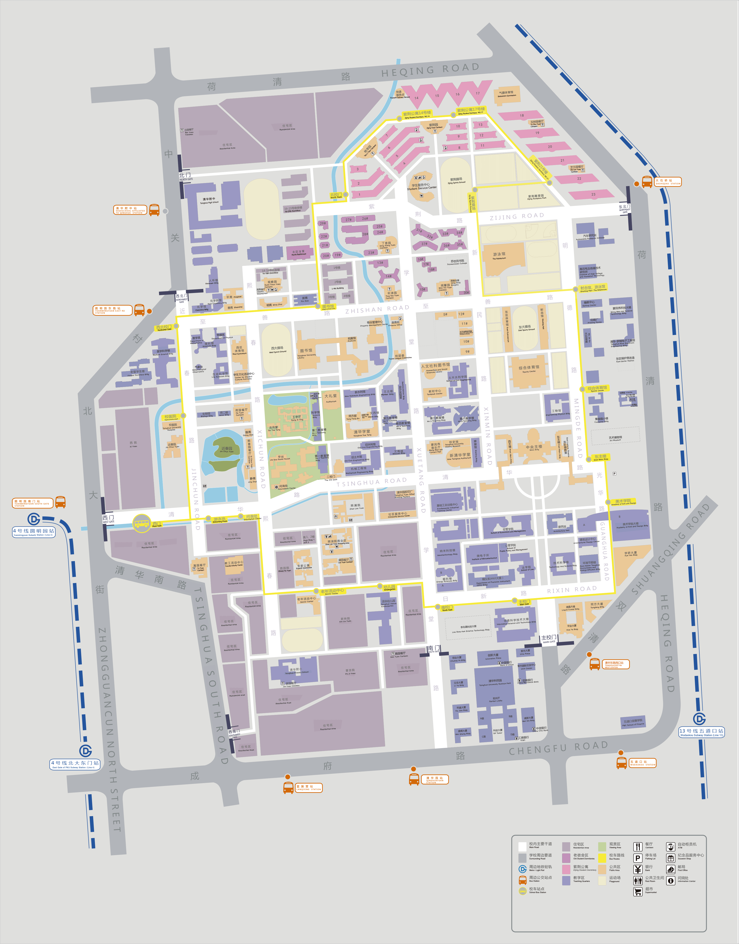
Jin Chun Yuan Hotel

JiaSuo Hotel

Northeast gate

Northwest gate

Wu Dao Kou Station

Yuan Ming Yuan Station

Main gate

South gate

West gate

YMSC, Jing Zhai building

